Baruch College, 7-13-20 Prof. L. Tatum
Corrections to variance and sd on page 3
Lecture Notes 1: An Introduction to R

Section Topic Pages
1 R Basics 1-2
2 Vectors 3-5
3 Matrices 6
4 Logical Operators 9
5 Special Functions 9
6 Data Frames 10-11
7 General Commands 12-14
8 Exercises 15-16

1. R BASICS

WINDOWS
To install R on Microsoft Windows, search for “R for Windows”. Click on the Download R for Window link. An example is shown below. R is updated several times a year; in the screenshot below, the versions are R-3.5.1 and R-3.4.1.
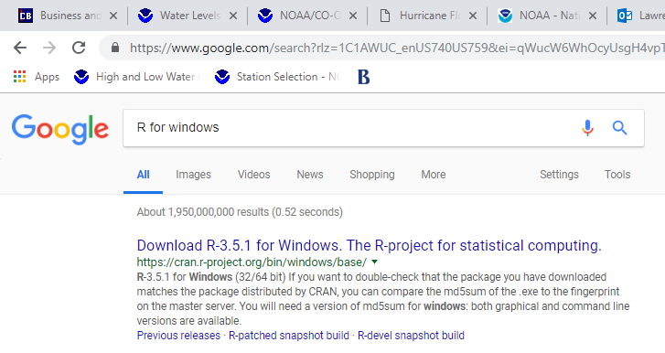

In the next screen, click on the circled Download option. Take defaults and see next step.
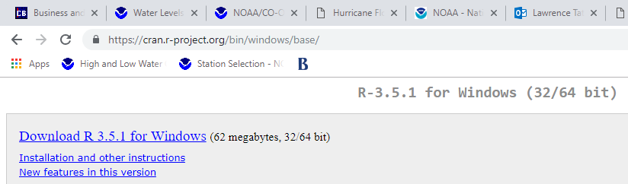

In this next screen, find the actual package for download, as circled below. However, you will probably find an updated version of R so you might see R-3.5.1 or later.
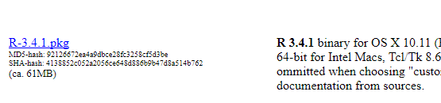

MAC Computers
On Mac computers, Google “R for mac” and you should come to this screen. Click circled link.

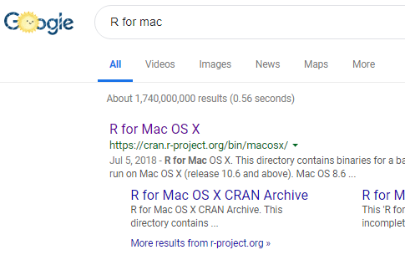

In the next screen, click the link circled below. However, R is frequently updated so the numbering may be higher. After that, take default options.

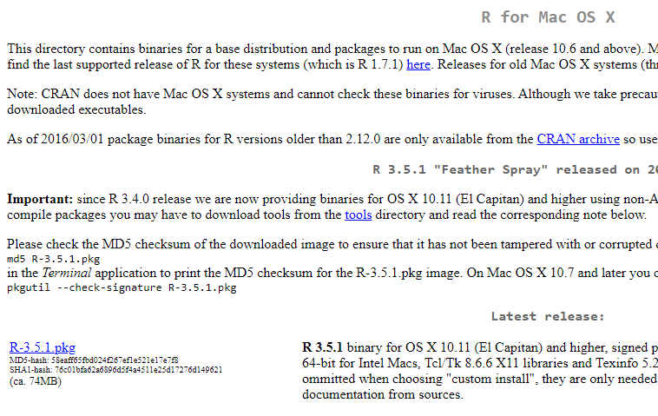

***********************************************
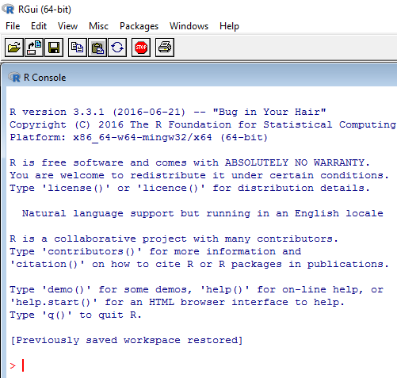
Starting R

After downloading and installing, when you start R, you will find yourself at the R Console, as shown on the right.
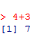
Type commands at the red prompt, >. For example, to use R as a simple calculator, we can add 4 and 3 by typing
4+3
at the prompt and hitting Enter.

2. VECTORS

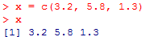
To create a data set named “x” containing values 3.2, 5.5, and 1.2, use the concatenation function, c( ), as shown on the right. We call x a vector.

To see what is in x, type x and hit Enter. Voila!
(The [1] in blue brackets tell us that the 3.2 is the first value. That is helpful when the vector wraps around to a second line.)

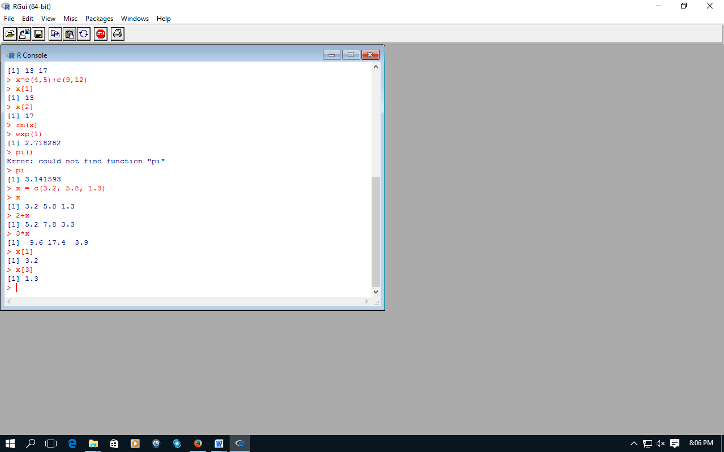
To add 2 to each element of this vector, we simply type 2+x; to multiply each element by 3, we type 3*x.

We could find the square root of each element using sqrt(x).
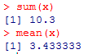
To get the sum of this vector we type sum(x); to get the average we type mean(x).

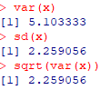
To get the sample variance, use var(x); for the sample standard deviation, use sd(x).

We can use the square root function, sqrt( ), to check that in fact the sample standard deviation is the square root of the sample variance!
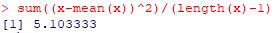
Finally, remind yourself that the sample variance is computed by subtracting the sample average from each observation, squaring those differences, adding them up, and dividing that sum by one less than the number of observations. That computation can be done in R as shown on the right. Note the answer, 5.103, matches that of the var function.

Note: We view the sample variance of an estimate of either the variance of a population or the variance of a random variable, depending on our choice of the type of model.
Use subscripts inside square brackets to select an individual term of a vector. For example,
x[2]
will give you the second value in the vector named x.

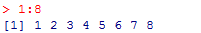
To generate a vector of integers 1 to 8, type 1:8.

Use the length function to find the length of a vector.

Generating Random Values from the Z-distribution

I am now going to generate a vector of standard Normal deviates of length n=9. These are simulated values drawn from a Normal distribution with µ=0 and σ=1. More information on the standard Normal distribution and simulations are on the next page. There is nothing special about my use of “Sim.Values” to denote my vector of simulated values – it is just a name.
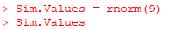

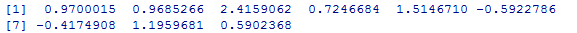

Students are often shocked when they copy the above commands because they do not get the same values as I did, but that is what we want! The whole point of “simulated” random outcomes is that they differ, unpredictably.
To understand what is happening, try using the above command without an assignment, to directly generate 9 random Normal deviates on their own:
> rnorm(9)
and then do that again, several times. Again, students are often surprised that they do not get the same values on repeated trials. But, not getting the same values is exactly the desired result when using a random generator. We are trying to study the characteristics of randomness and to that purpose we need functions that behave as if their source is random.

Important Fact #1: You do not need to repeatedly type in commands when experimenting with them. Instead, we can edit old commands. Use the up arrow key to go back to the desired command. Then, use the left arrow key to move across the command and edit as needed. Hit Enter at any point and it will execute.

Important Fact #2: R is case-sensitive. So, something called MyDAta will not be recognized if you call it MyData in a command. (Many of us will have trouble even seeing the difference between those two words!) The resulting errors will plague you, and plague everyone who uses R.

Important Fact #3: If you want to be able to replicate a set of random numbers in the future, then you can set the “seed” of the random number generator. In R, we do this using the “set.seed( )” function. As an example, I took the number 6242019 because it happens that I am writing this sentence on June 24, 2019. In the following R commands, you will see that whenever I insert the command “set.seed(6242019)” I will get the same sequence of random numbers from the “rnorm” function, even for a fresh call. The ISL text makes heavy use of that trick so that we can replicate their work even when it involves random number generation.
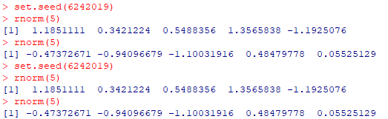

Amusing fact: there are three primary naming conventions in computer coding in which ordinary English terms are strung together. The first convention is use all lower case letters, as in mydata. The second is capitalize the first letter of each word, as in MyData; this is called upper camel, as in UpperCamel. The third is to capitalize all terms except for the first word, as in myData; this is termed lower camel, as in lowerCamel. It has been claimed by some researchers that lowerCamel is easier to read for those for whom English is not the first language.

3. MATRICES

There are two matrix-like formats used in R. The first format is for ordinary mathematical matrices, the second format is called a “data frame” and is able to do two special, extra things: it can hold both text and numbers, and it holds column names (and row names if desired). Thus, a data frame can contain non-numeric columns such as yes/no values or the names of cities or the names of months. Matrices, themselves, can only contain numeric data: no June or July allowed. Many R commands that work with matrices do not work on data frames and vice versa!
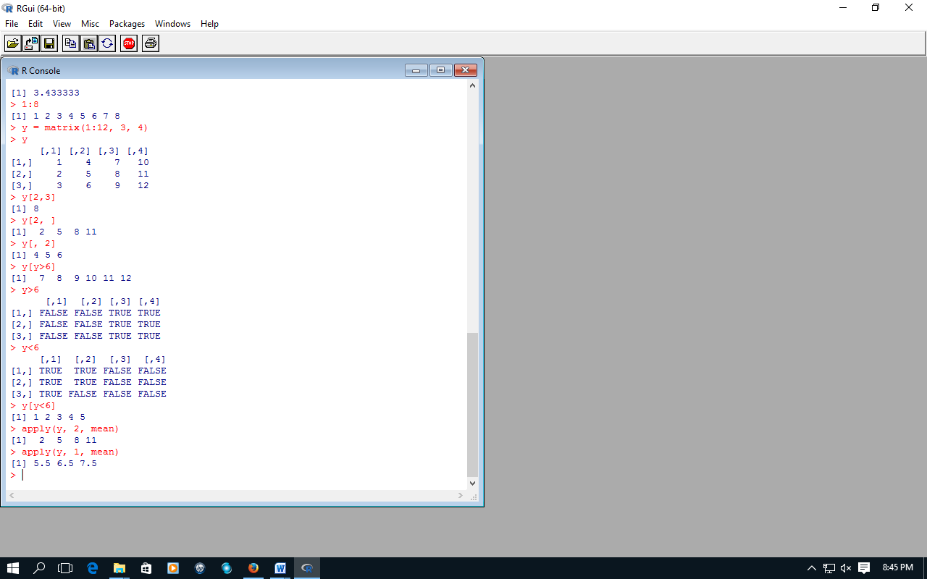
To create a 3x4 matrix (3 rows and 4 columns) named y and filled with the integer values 1 to 12, type
y=matrix(1:12, 3, 4)
as shown.

To select the element in the 2nd row, 3rd column.

Extract 2nd row.

Extract 2nd column.

Extract the column averages.

Extract the row averages.

Note: in the column average example, above, it so happens that the average of each column matches the entries for the second row. At little reflection may show you why this happened in this particular example.
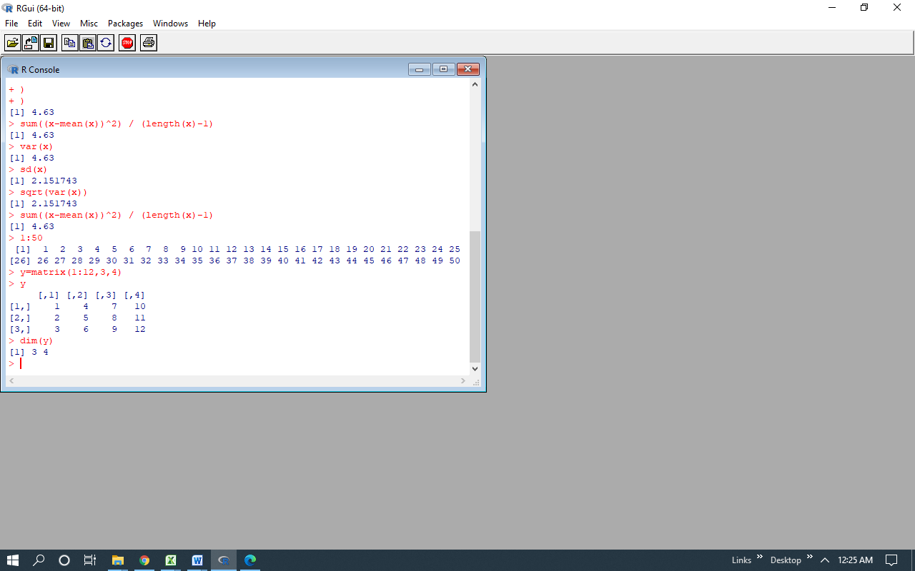
Use the “dim” function to get the dimensions of a matrix. Our y matrix was defined as having 3 rows and 4 columns: the dimensions-function, dim( ), agrees by reporting
3 4
which is understood to give the number of rows first.

4. LOGICAL OPERATORS

Becoming skilled in applying logical operators is important in R. It is critical to understanding the way R is used in ISLR textbook. In this example, I want to find the entries in the previous y-matrix which are less than 6. First, refresh your memory as to the contents of y, and then visually scan them to see which entries are less than six. How do we get R to give us just those values?

First, I type y<6, which R then evaluates on each of the 12 elements of y, asking each,
“Are you less than 6? True or False?”
R responds with a matrix the same size as y, but containing only TRUE or FALSE in each spot.

When we insert the “y<6” matrix into square brackets after y, we are asking R to return those entries in y that have a TRUE value in the matrix y<6.
Obviously, you are unlikely to understand that on the first try. Fortunately, as time goes on, R will give us opportunities to stretch our brains trying to understand how it uses arguments like the above to “pull rabbits out of hats.”
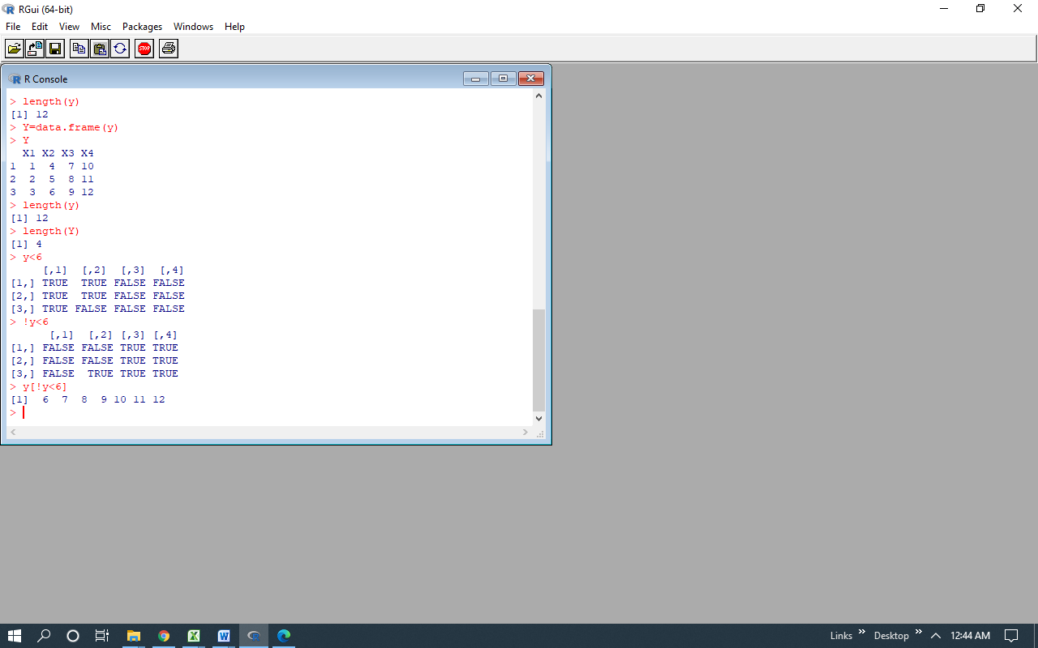
Another powerful logic function is the “not” command, denoted as “!” Let’s try to use it to get the values of y that are not less than 6. As an experiment, I will just try putting “!” in front of y<6. Wow, it worked. I have reversed the True and False entries.
Now, y[!y<6] should work get me the elements of y that are not less than 6. Yes, it does.

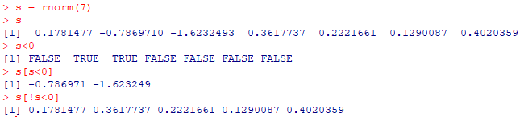
Recall our earlier vector, Sim.Values, with 9 standard Normal deviates. I am going to rename it as “s” and then show how to extract the negative entries. First, I put v equal to s<0. We now know that s<0 is a logic command and will return True and False for each entry of s. Thus, s[s<0] will return the two negative entries of s, while s[!s<0] will return the entries that are not negative.
These are powerful but tricky tools because it is easy to make a mistake.
5. THE SAMPLE FUNCTION

In statistics, we often wish to draw a random sample from the values in a list. We do this using the “sample” function. The sample function takes two arguments: the first is the number of values in the list, the second is the desired sample size. The statement
sample(7,3)
will return to us three values drawn at random (without replacement) from the integers 1 to 7. We can use that to pull out entries.

As an example, recall the s vector from above, which has 7 entries. I want to pull out 3 entries from s, randomly. Here, I am going to do this in two steps. First, I will use z to denote the output of the sample function, then I will show the content of z. You will see
7, 6, 4
which means that the 7th, the 6th, and the 4th elements of z will be selected.
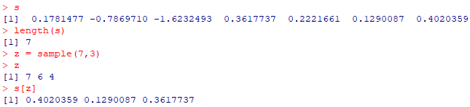
The command s[z] delivers those three, as promised!

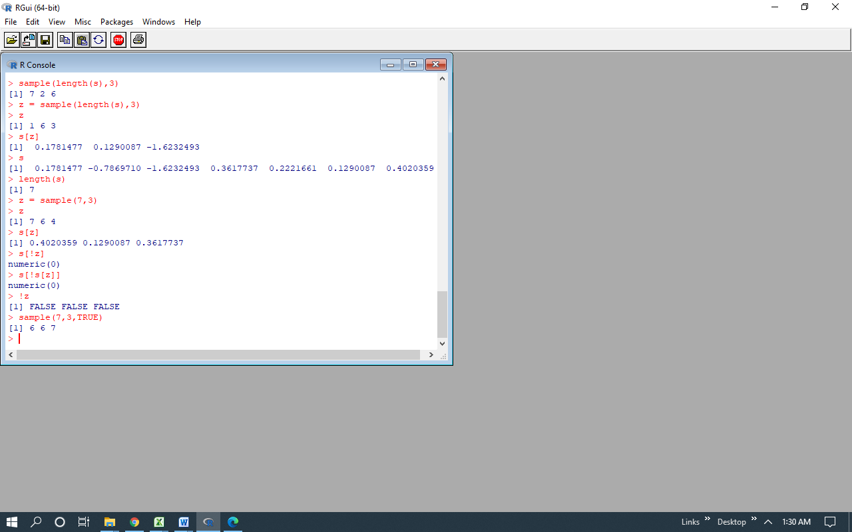
If we need to sample with replacement, we can add TRUE as a third argument to the sample function; you will see in the example below that in that output I did indeed get the 6 twice.
The default value of that third argument is FALSE. If you want, you can put FALSE in there when sampling without replacement, but it is not needed.

6. DATA FRAMES
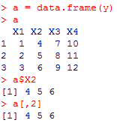
A data frame is like a matrix, but it is able to hold non-numeric data values and it has named columns. Here, I convert our y-matrix into a data frame using the data.frame function.
When that data frame is printed, we see it now has column titles. These were default values provided by R; ordinarily, we provide the row titles.
Note that we can call the entries in the second column by using $ and the name of that column:
a$X2.
We can still call the second column using the command
a[, 2]
as with a matrix.

We will usually be working with data frames rather than matrices.

The “Iris” data set is stored as a data frame in R under the name iris. It is automatically present whenever you open R. This is perhaps the most famous data set in the world because it is used in almost all multivariate statistics texts and most data mining texts, as well. The data was collected by a botanist named Edgar Anderson, principally on the Gaspe pennisula of Canada. The problem of interest to Anderson was the difficulty in distinguishing between the iris species Virginica and the iris species Versicolor – as I understand it, a third species, Setosa, was added by the renowned statistician R.A. Fisher when he used Anderson’s data to illustrate his pioneering work in multivariate classication methods. The data has 150 rows and 5 columns.
To see the first four rows of Anderson’s data, use the command >iris[1:4, ]:
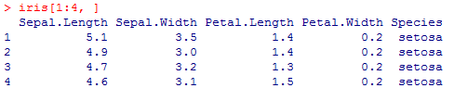

It is very pleasant to have column names; matrices do not support those.

7. GENERAL COMMANDS
To list the variables (and also functions) you have created in the current R console, type
ls( )
where the first symbol is the letter “el” not the number one. The parentheses are needed to indicate that is actually a function.
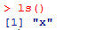

To remove a variable (or a function) you have created, use the remove function rm(). So, typing rm(x) would delete an element named x.

To find out the nature of a variable, use the “class” function. That will tell us if the variable is a vector, matrix, a data frame, or a non-numeric vector. To get more detailed information, particularly for data frames, use the “str” function. Here, under $ Species, we are told that the Species is a column name for a “factor” variable at three levels. Note the string of 1’s. The factors are stored as numeric values (here, 1, 2, and 3) but R understands that these are labels, not numbers. Setosa is factor level 1. It so happens that the iris data has been sorted by Species, so it starts with 50 Setosa flower measurements.
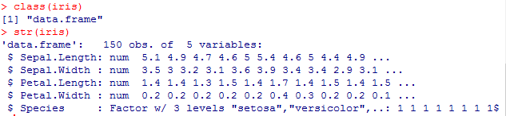
To get the column names of a data frame, use the “names” function, such as names(iris).

SAVING YOUR WORKSPACE in WINDOWS
In Microsoft Windows, on the top of the console, press the Save Workspace button. Then, give your workspace a name, say Rjunk.RData. You must include the suffix
.RData
without that, you will save nothing.
Now, where did it get saved on the computer? You can check by examining the command line that will appear in R, as shown below for my case.
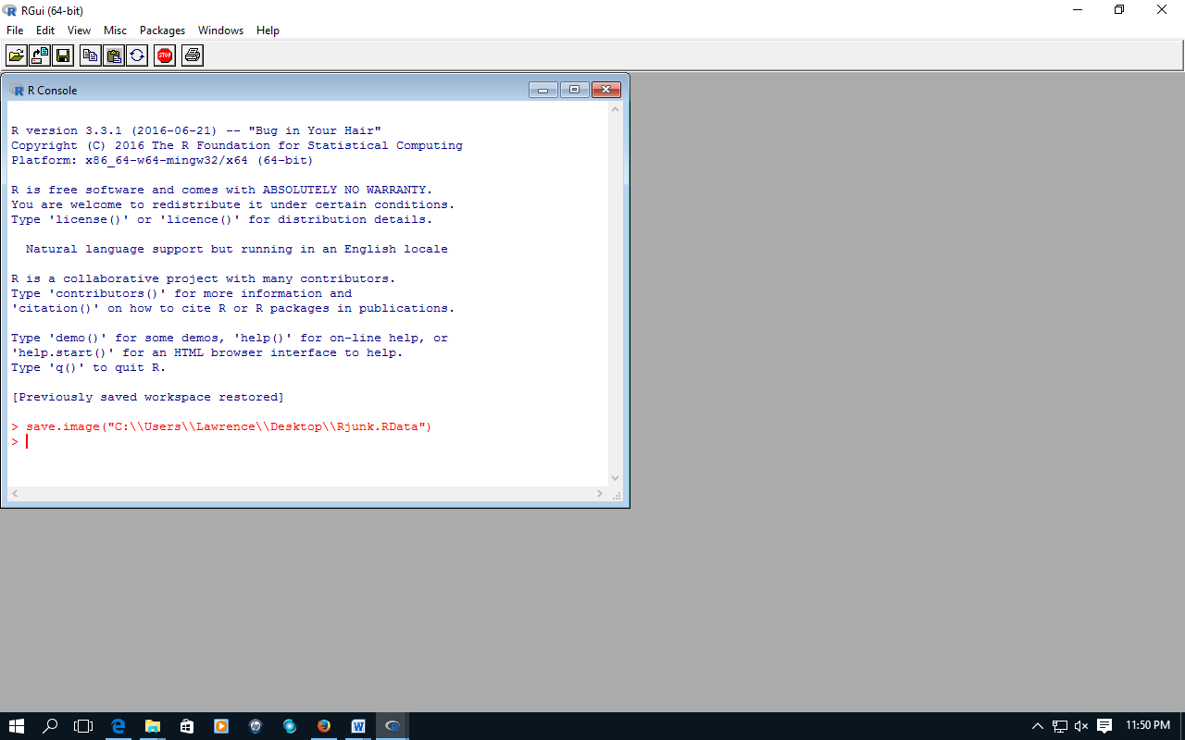
SAVING YOUR WORKSPACE in MAC
Go the Workspace on the upper line of your display, select
Save Workspace File...
and again make sure to put on the suffix
.RData
so that a possible file name would be
Junk.RData
R Help: to get help on a function like “sample” from within in R, type
>help(sample).
The result will be fairly technical – often unreadably so – but it comes from the proverbial horse’s mouth. Or, you can use
?sample
for the same purpose.

SAVING YOUR COMMAND HISTORY

On the top of the R console, click on File, Save History. Supply a name, say Rjunk History and hit Enter. As described below, though, I strongly recommend that you never save to the default directory.
Now, open a fresh R program. Go back to File, and select Load History. Select your history file, say Rjunk History.
If you do that correctly, nothing will be shown, yet! But, type
history()
and our original command-line history will be displayed. That will only go back to the last 25 commands. To get the last 50, use history(50), as I show below. To get all, use history(Inf), according to R help.
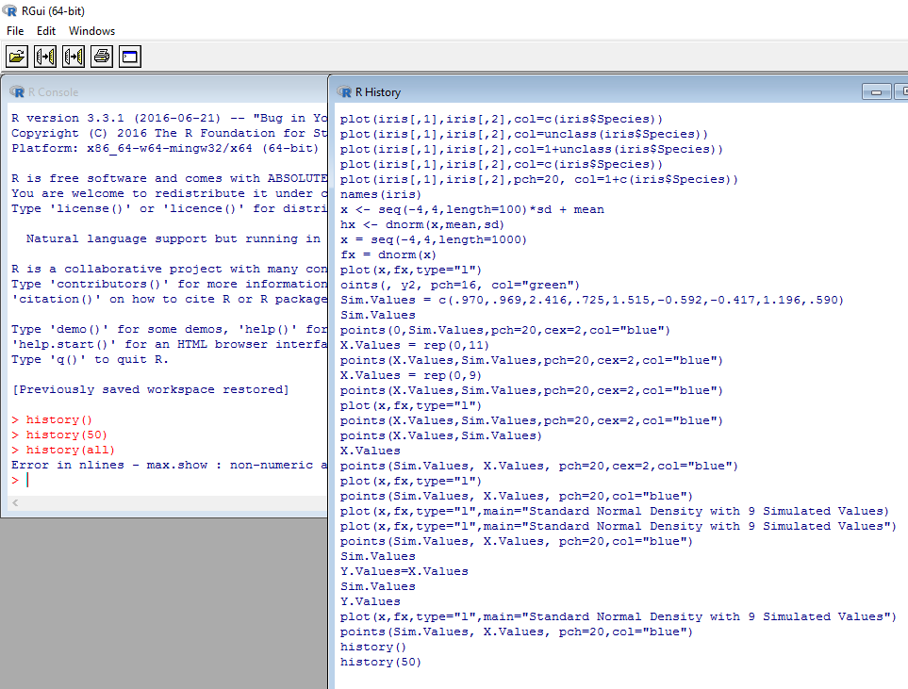

IMPORTANT WARNING ABOUT SAVING R.History
If you save your R History to your default R directory, then my experience is that this History will automatically load whenever you start R, no matter whether is a fresh R or a saved workspace. This is very annoying because when you use the up arrow, you will find a host of commands which you probably did not use in the intended file. Thus, my recommendation is to never save R.History to the current default directory because that is the source at which R will always start. Shove into a subdirectory.

SAVE TEXT
To save both your commands and the R responses, go to File and select “Save to File...”
That yields a text file that can be opened directly, unlike a history file that must be opened from within R. And, it contains more information!

UPDATING R

from https://www.r-statistics.com/2015/06/a-step-by-step-screenshots-tutorial-for-upgrading-r-on-windows/

There is a package called “installR” that does all the work of updating R. The site listed above shows reassuring screenshots, but I was able to do fine by starting with this single instruction screenshot:
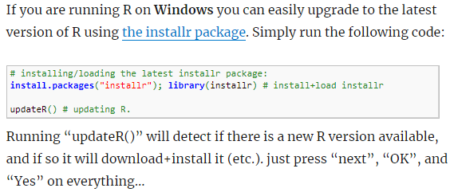

CHANGING DEFAULT WORKING DIRECTORY

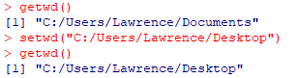
To find the location of the current working directory, use the command getwd(), as shown. To change the working directory to – for example - the Desktop, use the setwd() command as shown.

